



**TABLE OF CONTENTS**

1. Document Purpose 4

2. Solution Overview 4

3. Marking Tool 4

3.1. Plug-in installation 4

3.2. Opening multiple PDFs 4

3.3. Open Rubric button 4

3.4. Mark toolbar option 5

3.5. Tick toolbar option 6

3.6. Half-Tick toolbar option 7

3.7. Cross toolbar option 8

3.8. Read acknowledgement toolbar option 9

3.9. Deselect toolbar option 10

3.10. Commented mark toolbar option 10

3.11. Count toolbar option 12

3.12. Finalize button 14

4. Marking comment tool 14

4.1. File setup 15

4.1.1. Open 16

4.1.2. New 16

4.1.3. Save 16

4.1.4. Save As... 16

4.1.5. Exit 16

4.2. Element 16

4.3. Comments 17

4.4. Adding comments to PDF 17

4.5. Obtaining a new Rubric 18

4.6. Associate a Rubric with a particular course and assignment 18

4.7. Comment XML file domain model 20

5. Rubric Tool 21

5.1. Business Process 21

5.2. Domain Model 22

5.3. Rubric Logical Explanation 23

**FIGURES**

Figure 1: Mark toolbar icon 5

Figure 2: Mark dialog 5

Figure 3: Example mark on PDF 6

Figure 4: Tick toolbar icon 6

Figure 5: Tick dialog 7

Figure 6: Example tick on PDF 7

Figure 7: Half-Tick toolbar icon 7

Figure 8: Example half-tick on PDF 8

Figure 9: Cross toolbar icon 8

Figure 10: Example cross on PDF 9

Figure 11: Read acknowledgement toolbar icon 9

Figure 12: Example read acknowledgement on PDF 9

Figure 13: Deselect toolbar icon 10

Figure 14: Commented mark toolbar icon 10

Figure 15: Commented mark dialog 11

Figure 16: Example mark on PDF 12

Figure 17: Count toolbar icon 13

Figure 18: Assignment total dialog 13

Figure 19: Example results page 13

Figure 20: Marking comment tool 15

Figure 21: Commenting Tool – New Rubric for Lecturer 18

Figure 23: Comment XML file domain model 20

Figure 24: Rubric Tool Business Process 21

Figure 25: Rubric Tool Domain Model 22

Figure 26: Rubric Buttons and Fields 23

Figure 27: Filled in Rubric in Lecturer Mode 24

Figure 28: Rubric in Marker Mode 25

Figure 29: Rubric in Student Mode 25

Figure 30: Rubric Header 26

Figure 31: Rubric Footer 26

**TABLES**

Table 1: Approval Signatures 27

# Document Purpose

The purpose of a Functional Specification in the context of software development is to identify and describe the client’s requirements of which functionality the software should have and at a high-level how each piece of functionality should behave. A Functional Specification is used to form an agreement between the client and the software development team as to what functionality is expected by the client and what should be delivered by the development team.

A Functional Specification should be written using language and diagrams that is understandable to a non-technical audience.

The Functional Specification should be signed off before the software is delivered to formalise the agreement between the client and the software development team. The document is thus signed off by both parties. In longer projects, functional specification documents tend to change over time and as a result, a version of the functional specification should be signed off before the software of a sprint/milestone is delivered.

# Solution Overview

The entire UNISA marking solution is divided into three logical components:

* Marking Tool
* Commenting Tool
* Assignment Rubric

Each of these solution components is described in detail below.

Operating functionality and interaction between the three tools will be built in, but each component could function on its own as well.

# Marking Tool

This section defines the functionality of the Marking Tool, which is integrated as a plug-in into Adobe Acrobat Professional. The plug-in will be developed and tested for Adobe Acrobat Professional version 9/10/11, but some functionality may work in older versions of Adobe Acrobat Professional.

The following sub sections of the specification identify and describe the various functions of the Adobe Acrobat Professional Plug-in.

## Plug-in installation

To install the acrobat plug-in run the “Marking Tool v1.6 Installer.exe”. The default installation options in the installer application should be correct for most installations. The “Marking Tool v1.6 Installer.exe” plug-in can be installed on both Acrobat 9/10/11 and both Windows XP and Windows 7 32 bit operating systems.

## Opening multiple PDFs

Due to technology design, the Acrobat Java Script will only work for a single PDF file at a time. The user must ensure that only one PDF is opened in Acrobat Professional at a time. If however a second PDF in opened in Acrobat Professional, the second PDF will open and the marking toolbar will be visible, but the marking toolbar options will not work in the second PDF. If for example the count toolbar option is used in the second PDF, the marks in the first PDF will be counted and the results page will be added to the first PDF.

## Open Rubric button

On the first page in the bottom left hand corner of every currently marked assignment a button will placed with the label “Open Rubric”.

Should the particular assignment you are marking use a rubric for marking purposes (or if it is your marking style and you have setup a rubric for this assignment), click this button to open the PDF document assignment rubric for marking purposes.

If a rubric has not being associated for the particular assignment you are using and you click this button, you will simply receive a message detailing that you should setup a rubric via the commenting tool.

**File rename:**

The rubric’s filename will be renamed to be identical to the current assignment’s filename, with the postfix “_**RUBRIC**” being added as well. If the assignment’s name is “**filename.pdf**”, the rubric’s filename will become “**filename_ RUBRIC.pdf**”.

**To setup a rubric**:

For use with a particular course & assignment number combination (eg: CEM1010 Assignment 4), please see the appropriate section in the commenting tool section (4.5)

## Mark toolbar option

The purpose of the mark toolbar option is to allow a lecturer/teaching assistant marking an assignment to add a mark to a PDF. The mark’s number of points should be clearly visible on the PDF, but also accessible from code, so that all the marks can later be added together programmatically.

The mark toolbar option will be represented on the Adobe Acrobat Professional toolbar by the following icon:



Figure 1: Mark toolbar icon

The mark toolbar option will be used by way of the following process:

1. Select the Mark toolbar icon.
2. Click in the PDF document on the spot where the mark is to be inserted.
3. The pop-up window similar to the following screenshot will appear.

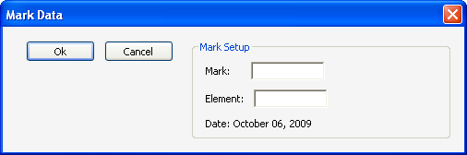

Figure 2: Mark dialog

1. Enter the mark scored for the Element (e.g. 5). The mark scored must be in the range from -100 to 100, but decimal values of .5 (point 5) may be used, e.g. 2.5. The user can optionally enter an element as well. If the Element is entered, the count toolbar option will display additional detail of the score breakdown in the results page. The default value of the Element will be the last specified Element in the PDF file.
2. Click the OK button.
3. The mark will appear on the PDF as per the following example.

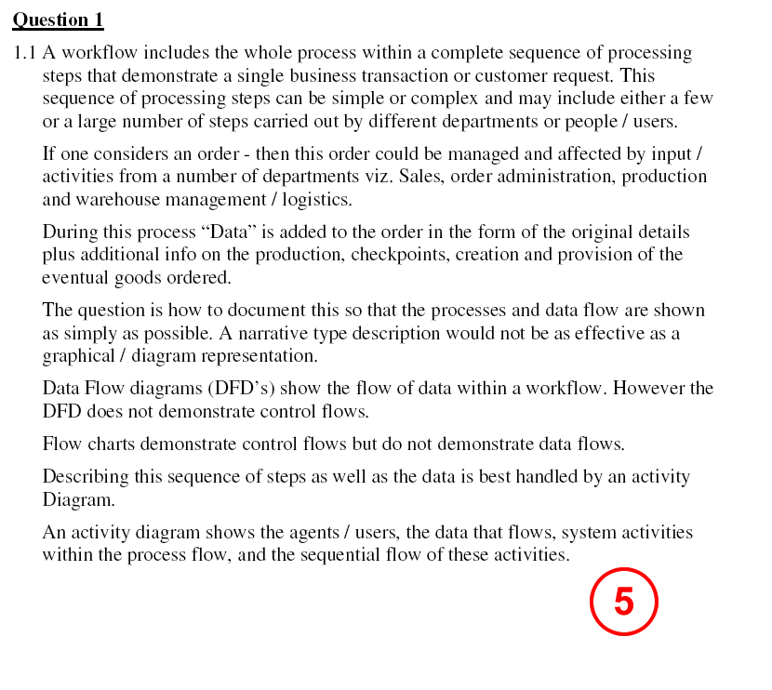

Figure 3: Example mark on PDF

1. (OPTIONAL) The colour of the mark can be changed by right clicking the mark.
2. (OPTIONAL) Select the **Properties...** option from the popup menu.
3. (OPTIONAL) On the **Appearance** tab, click the button next to the **Color** label.
4. (OPTIONAL) Select the desired colour.
5. (OPTIONAL) If you want all subsequent marks, ticks, half-ticks, crosses and read acknowledgements to use the selected colour, then select the **Make Properties Default** tick box.
6. (OPTIONAL) Select the **OK** button.

## Tick toolbar option

The purpose of the tick toolbar option is to allow a lecturer/teaching assistant marking an assignment to add a tick to a PDF. A tick will by default count one mark scored, but the user could specify a different score for a tick. The tick should be clearly visible on the PDF, but also accessible from code, so that all the marks can later be added together programmatically. The tick toolbar option differs from the mark toolbar option in that a tick cannot be associated to a specific Element number.

The tick toolbar option will be represented on the Adobe Acrobat Professional toolbar by the following icon:



Figure 4: Tick toolbar icon

The tick toolbar option will be used by way of the following process:

1. Select the Tick toolbar icon.
2. A dialog is displayed where the user specifies how much a tick will count. By default a tick will count 1 mark.

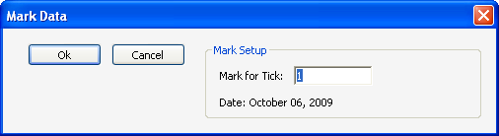

Figure 5: Tick dialog

1. Click in the PDF document on the spot where the tick is to be inserted.
2. The tick will appear on the PDF as per the following example.

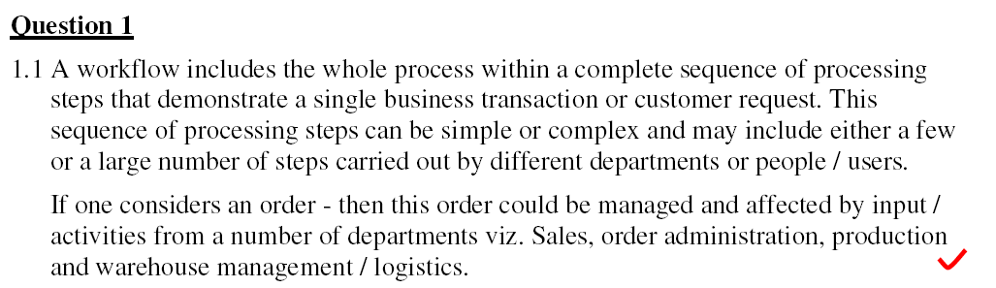

Figure 6: Example tick on PDF

1. The tick will remain selected in the marking toolbar until it is deselected by using either the deselect, mark or count toolbar options.
2. (OPTIONAL) The colour of the tick can be changed by right clicking the tick.
3. (OPTIONAL) Select the **Properties...** option from the popup menu.
4. (OPTIONAL) On the **Appearance** tab, click the button next to the **Color** label.
5. (OPTIONAL) Select the desired colour.
6. (OPTIONAL) If you want all subsequent marks, ticks, half-ticks, crosses and read acknowledgements to use the selected colour, then select the **Make Properties Default** tick box.
7. (OPTIONAL) Select the OK button.

## Half-Tick toolbar option

The purpose of the half-tick toolbar option is to allow a lecturer/teaching assistant marking an assignment to add a half-tick to a PDF. A tick will always count half (0.5) a mark scored. The half-tick should be clearly visible on the PDF, but also accessible from code, so that all the marks can later be added together programmatically. The half-tick toolbar option differs from the mark toolbar option in that a half-tick cannot be associated to a specific Element number.

The half-tick toolbar option will be represented on the Adobe Acrobat Professional toolbar by the following icon:



Figure 7: Half-Tick toolbar icon

The half-tick toolbar option will be used by way of the following process:

1. Select the Half-Tick toolbar icon.
2. Click in the PDF document on the spot where the half-tick is to be inserted.
3. The half-tick will appear on the PDF as per the following example.

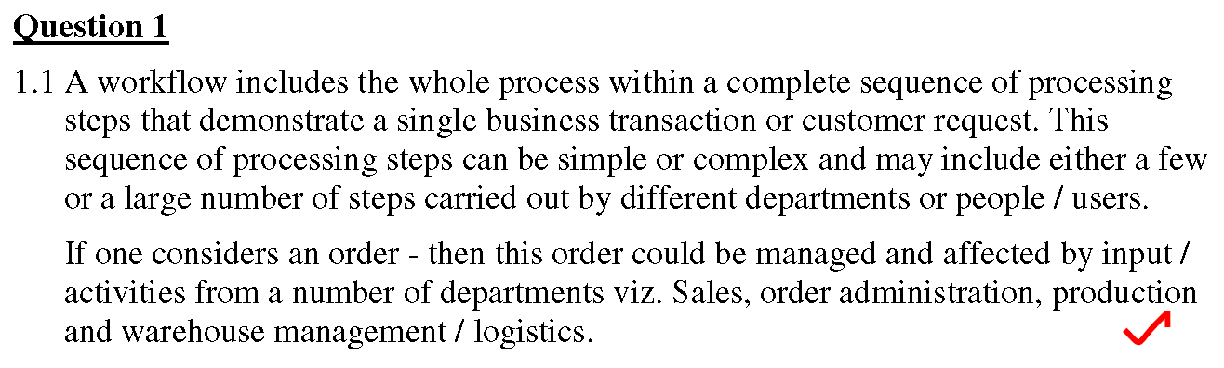

Figure 8: Example half-tick on PDF

1. The half-tick will remain selected in the marking toolbar until it is deselected by using either the deselect, mark or count toolbar options.
2. (OPTIONAL) The colour of the half-tick can be changed by right clicking the half-tick.
3. (OPTIONAL) Select the **Properties...** option from the popup menu.
4. (OPTIONAL) On the **Appearance** tab, click the button next to the **Color** label.
5. (OPTIONAL) Select the desired colour.
6. (OPTIONAL) If you want all subsequent marks, ticks, half-ticks, crosses and read acknowledgements to use the selected colour, then select the **Make Properties Default** tick box.
7. (OPTIONAL) Select the **OK** button.

## Cross toolbar option

The purpose of the cross toolbar option is to allow a lecturer/teaching assistant marking an assignment to add a cross to a PDF. A cross will always count zero marks scored. The cross should be clearly visible on the PDF, but also accessible from code, so that all the marks can later be added together programmatically. The cross symbol will be equivalent to a mark with a score of zero.

The cross toolbar option will be represented on the Adobe Acrobat Professional toolbar by the following icon:



Figure 9: Cross toolbar icon

The cross toolbar option will be used by way of the following process:

1. Select the Cross toolbar icon.
2. Click in the PDF document on the spot where the cross is to be inserted.
3. The cross will appear on the PDF as per the following example.

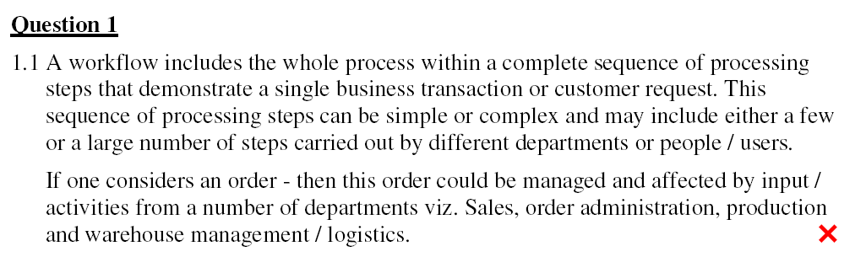

Figure 10: Example cross on PDF

1. The cross will remain selected in the marking toolbar until it is deselected by using either the deselect, mark or count toolbar options.
2. (OPTIONAL) The colour of the cross can be changed by right clicking the cross.
3. (OPTIONAL) Select the **Properties...** option from the popup menu.
4. (OPTIONAL) On the **Appearance** tab, click the button next to the **Color** label.
5. (OPTIONAL) Select the desired colour.
6. (OPTIONAL) If you want all subsequent marks, ticks, half-ticks, crosses and read acknowledgements to use the selected colour, then select the **Make Properties Default** tick box.
7. (OPTIONAL) Select the **OK** button.

## Read acknowledgement toolbar option

The purpose of the read acknowledgement toolbar option is to allow a lecturer/teaching assistant marking an assignment to add an indication to the PDF that a particular part of the assignment was read. A read acknowledgement will not count as any marks scored and is ignored but the count toolbar option. The read acknowledgement should be clearly visible on the PDF.

The read acknowledgement toolbar option will be represented on the Adobe Acrobat Professional toolbar by the following icon:



Figure 11: Read acknowledgement toolbar icon

The read acknowledgement toolbar option will be used by way of the following process:

1. Select the read acknowledgement toolbar icon.
2. Click in the PDF document on the spot where the read acknowledgement is to be inserted.
3. The read acknowledgement will appear on the PDF as per the following example.

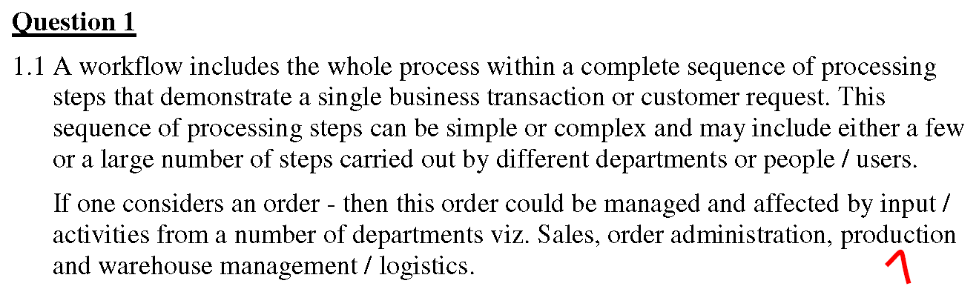

Figure 12: Example read acknowledgement on PDF

1. The read acknowledgement will remain selected in the marking toolbar until it is deselected by using either the deselect, mark or count toolbar options.
2. (OPTIONAL) The colour of the read acknowledgement can be changed by right clicking the read acknowledgement.
3. (OPTIONAL) Select the **Properties...** option from the popup menu.
4. (OPTIONAL) On the **Appearance** tab, click the button next to the **Color** label.
5. (OPTIONAL) Select the desired colour.
6. (OPTIONAL) If you want all subsequent marks, ticks, half-ticks, crosses and read acknowledgements to use the selected colour, then select the **Make Properties Default** tick box.
7. (OPTIONAL) Select the **OK** button.

## Deselect toolbar option

The deselect toolbar option is used to deselect the tick, half-tick, cross, read acknowledgement and mark toolbar options if those toolbar options are selected.

The deselect toolbar option will be represented on the Adobe Acrobat Professional toolbar by the following icon:



Figure 13: Deselect toolbar icon

## Commented mark toolbar option

The purpose of the commented mark toolbar option is to allow a lecturer/teaching assistant marking an assignment to add a mark to a PDF. The mark’s number of points should be clearly visible on the PDF, but also accessible from code, so that all the marks can later be added together programmatically. The mark will also contain a pop-up note which contains a comment from the marking comment tool described in Section 4.

The commented mark toolbar option will be represented on the Adobe Acrobat Professional toolbar by the following icon:



Figure 14: Commented mark toolbar icon

The mark toolbar option will be used by way of the following process:

1. Select the Commented mark toolbar icon.
2. Click in the PDF document on the spot where the mark is to be inserted.
3. The pop-up window similar to the following screenshot will appear.

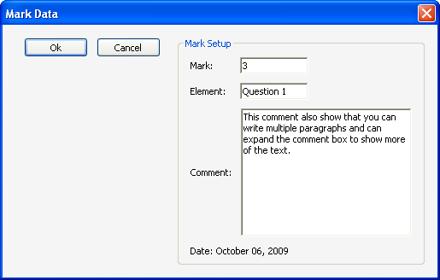

Figure 15: Commented mark dialog

1. The mark scored, Element and comment will be pre-populated from the “Copy to marking tool” option in the marking comment tool. The values can be edited if required.
2. Click the OK button.
3. The mark will appear on the PDF as per the following example.

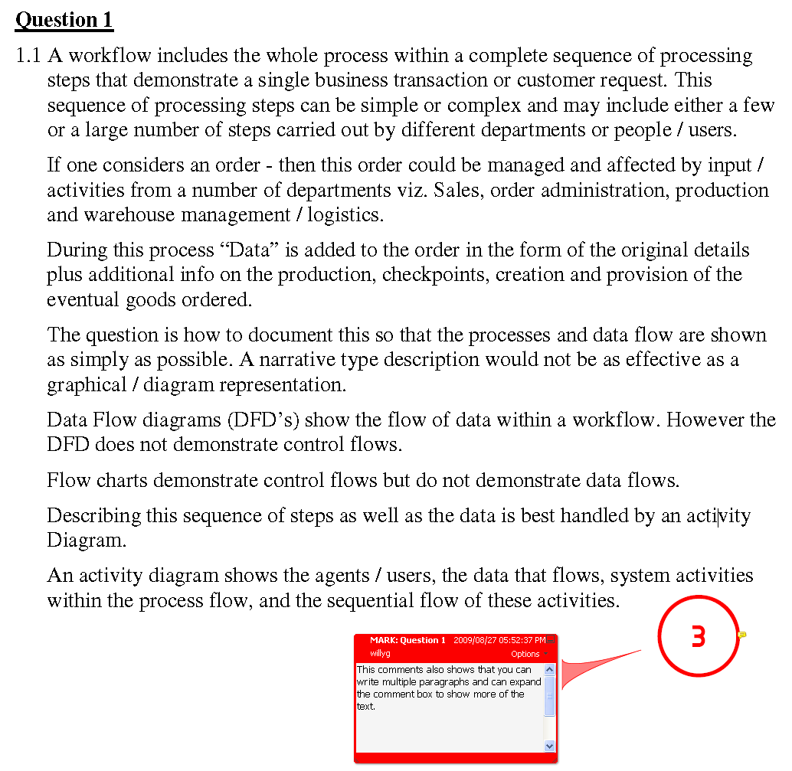

Figure 16: Example mark on PDF

1. (OPTIONAL) The colour of the mark can be changed by right clicking the mark.
2. (OPTIONAL) Select the **Properties...** option from the popup menu.
3. (OPTIONAL) On the **Appearance** tab, click the button next to the **Color** label.
4. (OPTIONAL) Select the desired colour.
5. (OPTIONAL) If you want all subsequent marks, ticks, half-ticks, crosses and read acknowledgements to use the selected colour, then select the **Make Properties Default** tick box.
6. (OPTIONAL) Select the OK button.

## Count toolbar option

The purpose of the count toolbar option is to allow a lecturer/teaching assistant marking an assignment to add all the marks and ticks together to calculate the total marks scored for the assignment. The total marks scored will be displayed at the end of the assignment in a new page that will be added when clicking the count toolbar icon.

Should the marker be using a rubric for marking purposes, the count toolbar button should only be used once the rubric is FINALIZED and SAVED.

The count toolbar option will be represented on the Adobe Acrobat Professional toolbar by the following icon:

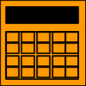

Figure 17: Count toolbar icon

The count toolbar option will be used by way of the following process:

1. Select the count toolbar icon.
2. A dialog is displayed asking the marker whether they are making use of a rubric.
   1. If marker selects NO, continue with Step 3 below.
   2. If marker selects YES, continue with Step **10** below.
3. A dialog is displayed where the total marks out of which the assignment counts is specified. The default value for the assignment total is obtained from the Marking Comment Tool.

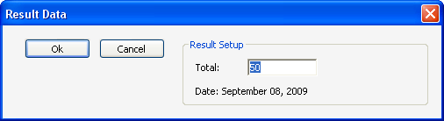

Figure 18: Assignment total dialog

1. Scroll to the last page in the PDF to view the results page.
2. The following screen shot shows an example results page with a breakdown of marks per Element.

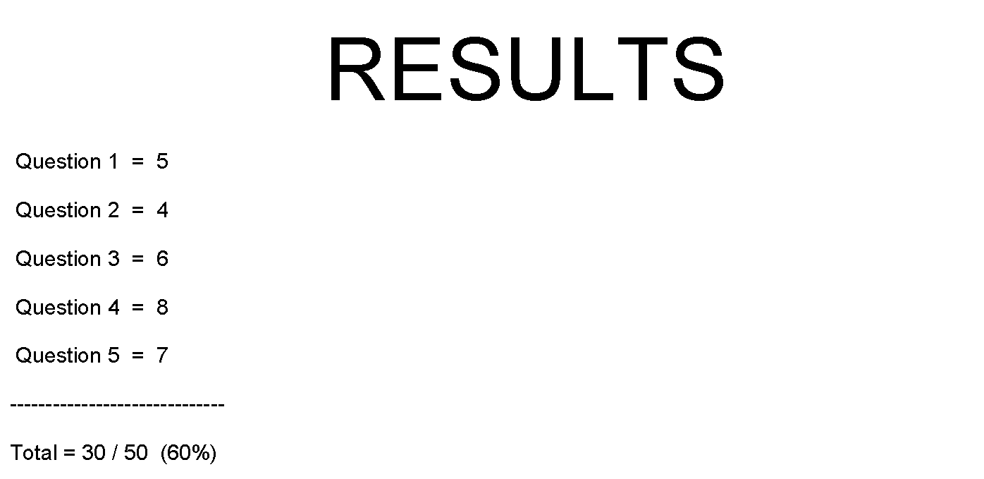

Figure 19: Example results page

1. This is the end of the process **not** using a Rubric (do **not** continue with step 10 below)

**<RUBRIC STEPS>**

1. The marking tool now queries the rubric to see if it is finalized and saved.
   1. if rubric is not finalized an error message is displayed and the process now has to start at step 1 again.
2. The finalized rubric is now renamed appropriately and is attached to the current opened assignment.
   1. **filename.pdf** becomes **filename_MARK*nnn*100_Rubric.pdf** where ***nnn*** is the percentage.
3. A results page is now created on the last page, displaying the percentage obtained from the rubric.
4. One can now view the rubric, by clicking on the Attachments icon in Adobe Acrobat Pro.
5. The assignment now contains an attached rubric - this is the end of the process using a Rubric.

**NOTE**: After the count toolbar button is clicked, one should proceed directly to the Finalize button.

## Finalize button

After the Count toolbar option is used, a results page is generated as per Figure 19. In the bottom left corner of the results page, there is a finalize button. Click the finalize button to finalize the PDF (finalize assignment marking and make the allocated marks ready for upload).

The file will be saved under a different name. The following naming convention is used for the new file name. If for example the PDF being marked was called **filename.pdf** and the student scored a mark of **20** out of a total of **40** marks (50%), the marking tool would calculate the percentage that was obtained and the file would be saved under the name **filename_MARK050100.pdf**.

No decimals will be allowed or accounted for in the filename, only whole numbers. The rounding up rule applies as follows and only accounts for the first decimal digit:

0.5 will round up to the next whole digit, 0.4 will round down to the current whole digit.

Examples:

49.49 = 49% = **filename_MARK049100.pdf**

78.50 = 79% = **filename_MARK079100.pdf**

After the file is saved under the new name, one or more comments pages are added to the end of the PDF. The comments pages display the text from the pop-up notes of all PDF annotations. Each comment text item has a number next to it and the same number is placed on the original annotation in the PDF. If the PDF is thus printed out, the reader will be able to reference which annotations are linked to which comment text. If the PDF contains an attached rubric, and the PDF is printed out, only the PDF is printed.

Finally, when a PDF is finalized, the marking toolbar will be hidden thus not allowing any further marking changes.

# Marking comment tool

In order to address the user requirement to manage a set of standard comments per assignment Element and to easily insert these standard comments into a PDF document while marking, the Marking comment tool will be developed.

The marking comment tool is designed to create a collection of standard comments that can be added to an assignment during the marking process. The standard comments are saved in an XML file indicating the course and assignment names. The comments are grouped by assignment Element.

The figure below is a screen capture to assist in describing the functionality of the marking comment tool.

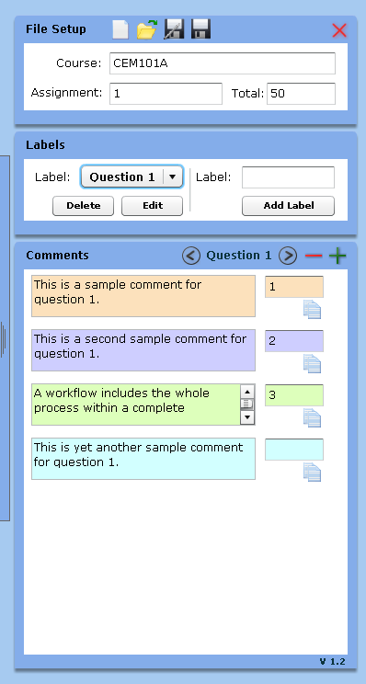

Figure 20: Marking comment tool

The following sub sections describe the various functions of the marking comment tool.

## File setup

The file setup is used to access functions related to the XML based comments files used by the marking comment tool. The file setup section appears at the top of the marking comment tool.

The marking comment tool is designed to have a separate comments file for every assignment. A comments file clearly states the name of the course and the name of the assignment to which the comments apply.

The comments file also states the total marks out of which the assignment counts. If a comments file is open in the Marking Comment Tool, then if the Count toolbar option is used in the Marking Tool, then the total from the Marking Comment Tool is used to pre-populate the assignment total dialog of the Count toolbar option.

### Open

To open an existing comments file, select the open option from file setup. A browse file dialog is displayed where the user can search for the file anywhere on the computer’s file system. Comments files always have a file extension of XML, for example ***CEM101A_1.xml***. Select an xml file from the file system and click the open button.

If a valid xml file was selected it will be opened, but if an invalid xml file was selected an error message will be displayed. When a valid comments file is opened, the name of the course and assignment is displayed in the comments file panel.

### New

To create a new comments file, select the new option from file setup. If the latest changes in the comments file that is currently open has not been saved, a dialog will be displayed where the user can choose to:

* Save the latest changes to the open comments file and create a new comments file.
* Do not save the latest changes to the open comments file and create a new comments file.
* Cancel the creation of a new comments file.

If a new comments file is created, the user must type the name of the course and the name of the assignment. The new comments file is not persisted (saved) to the file system until the Save or Save As options are used.

### Save

To save an open comments file, select the save option from file setup. If the open comments file has previously been persisted (saved) to the file system, the file on the file system is overwritten. If the open comments file has not previously been persisted (saved) to the file system, the save as file dialog is displayed.

### Save As...

To save a new open comments file or to save a previously saved open comments file under a different file name, select the save as option from file setup. A save as dialog is displayed where the user can select the file path and type the file name. A default file name will be suggested in the save as dialog and the default name will be the course name followed by an underscore character followed by the assignment name. Comments files always have a file extension of XML, for example ***CEM101A_1.xml***. The save button in the save as dialog is clicked to confirm the selected path and file name and the file is persisted (saved) to the file system.

If the Save As function is used and the user has not specified a course and/or assignment name, a dialog should be displayed notifying the user that the course and assignment name is compulsory.

### Exit

The exit option is selected to close the marking comment tool. If there is an open comments file where the latest changes have not been saved, a dialog is displayed where the user can select to:

* Save the changes and exit the marking comment tool.
* Do not save the changes and exit the marking comment tool.
* Cancel the exit function and do not save the current comment file.

## Element

The Element section of the marking comment tool serves to select, add, edit or delete elements for which comments are saved. An element is a generic word used to group a collection of comments. For example the element “Question 1” is an element that groups a collection of comments relating to question 1 of the assignment.

To select an element, first open the correct comments file if it is not yet open and then simply pick the element name from the drop down list. When an element is selected from the drop down list, the comments section will be become available.

To add an element, type the element name in the provided field and click the add element button. The element is added to the drop down list of elements and it is selected. An element name may not exceed 18 characters.

To edit an element, select the element from the drop down list and click the edit button. An onscreen dialog will appear where the new element name can be typed. The current element name will be displayed in the dialog. Type the new name of the element and click the update element button. The element name is updated in the drop down list of elements and it is selected.

To delete an element, select the element from the drop down list and click the delete button. A dialog will appear where the element name is displayed and the user is asked to confirm the deletion of the element. Click the OK button to confirm the deletion or click the Cancel button to cancel the deletion. If the deletion is confirmed, the element and all its sub comments are deleted.

## Comments

The comments section of the marking comment tool serves to select, add, edit or delete comments.

To select a comment, first select the correct element and then simply pick the comment from the list. When a comment is selected from the list, the selected comment is copied to the clipboard of the operating system.

To add a comment, first select a element and then click the add comment option. An additional comment will appear in the list of comments and the comment text can be typed. Type the comment text. Comment text up to 4930 characters is allowed and longer comments would not be able to paste into Acrobat pop-up notes. The user can also optionally specify a mark associated with the comment, which is used in conjunction with the commented mark Acrobat plug-in.

To edit a comment, select the comment from the list of comments. The cursor will appear in the comment box. Type the new comment text.

To delete a comment, select the comment from the list of comments and click the delete option. A dialog will appear where the comment is displayed and the user is asked to confirm the deletion of the comment. Click the OK button to confirm the deletion or click the Cancel button to cancel the deletion. If the deletion is confirmed, the comment is deleted. If the delete option is selected and the comment text is empty, the comment will be deleted without a dialog being displayed.

To copy a comment to the memory of the Commented mark toolbar option

## Adding comments to PDF

As discussed in section 4.3 above, when a comment is selected in the list it is copied to the operating system clipboard. To add a comment to a PDF, the following process can be followed:

1. Select a comment from the list as per section 4.3.
2. In Adobe Acrobat Professional, select for example a **Sticky Note**.
3. Click on the appropriate place in the PDF where the sticky note is to be added.
4. The sticky note is added to the PDF and the popup note is opened.
5. Right click on the popup note.
6. Select the **Paste Text** option from the popup menu.
7. The comment is pasted into the popup note.
8. (OPTIONAL) The pasted comment text can be edited in the popup note if required.
9. (OPTIONAL) The colour of the sticky note and its popup note can be changed by right clicking the sticky note or its popup note.
10. (OPTIONAL) Select the **Properties...** option from the popup menu.
11. (OPTIONAL) On the **Appearance** tab, click the button next to the Color label.
12. (OPTIONAL) Select the desired colour.
13. (OPTIONAL) If you want all subsequent sticky notes to use the selected colour, then select the **Make Properties Default** tick box.
14. (OPTIONAL) Select the **OK** button.

## Obtaining a new Rubric

As a lecturer or senior marker, you may have the requirement to use a rubric for marking purposes.

This process will take you through getting a new Rubric, so that you can set it up.

1. Fill in Course / Assignment fields **or** load an existing comments file (xml file)
2. Click the capital cursive R button on the File Setup pane to show the Rubric Setup pane
3. Click the capital cursive blue M button.
4. A “Save As” screen will popup – you must now save your new rubric to location. Click OK once you are satisfied.
5. The new PDF rubric will now be opened in your internet browser (**no** internet connection required)
6. Complete the rubric as required and then click the Save button (top left hand corner)
7. A “Save a Copy...” dialog will appear – you must now save your new rubric to location, that you will chose.
8. Change the file name to be different from what currently appears in this field.
   1. Please remember this location and filename, as you will need to find your newly created rubric to send out to other markers / assistant markers.
   2. Example: If it shows: Science_6.pdf, you could change it to **Science_6_RubricComplete.pdf**
9. Click “Save”.
10. You are now ready to use this rubric / send this rubric to other assistant markers.
11. 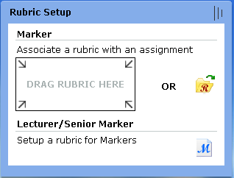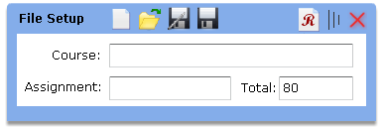

Figure 21: Commenting Tool – New Rubric for Lecturer

## Associate a Rubric with a particular course and assignment

Some assignments or markers’ marking style require a rubric to assess and mark an assignment. Detailed here are the steps to associate a rubric to a specific course and assignment combination (eg: CEM101 Ass 4).

1. Ensure the issued PDF rubric from the Lecturer / Senior marker is on your pc’s harddrive in a known location.
2. Fill in Course / Assignment fields **or** load an existing comments file (xml file)
3. Click the capital cursive R button on the File Setup pane to show the Rubric Setup pane
4. Drag and drop the PDF rubric into the designated rectangle that says: “DRAG RUBRIC HERE”.
   1. The rectangle will glow GREEN if it detects a PDF document.
   2. The rectangle will glow RED if it detects a non-PDF document (it will reject this file)

**OR**

1. Click the yellow folder with a capital cursive R button to browse to the issued PDF rubric, click OK
2. The rubric will now be moved to a special location for future use.
3. The rubric is now ready for use when you mark assignments for that course and assignment combination.

**NOTE:**

The capital cursive R button is GREEN if it has an associated rubric.

The capital cursive R button is RED if it doesn’t have an associated rubric (as per image below).



Figure 22: Commenting Tool – Rubric Setup

**Tip:**  Should you wish to overwrite the existing associated rubric, repeat the above steps again.

**To open the rubic:**

Open an assignment, on the first page in the bottom left hand corner of the assignment a button will be placed with the label “Open Rubric”. Click this button to view the associated rubric.

## Comment XML file domain model

The following figure shows the domain model that applies to the XML data stored in a comments file.



Figure 22: Comment XML file domain model

# Rubric Tool

The following section describes the functionality of the Rubric tool. A rubric is useful for marking assignments that are not in written form or written assignments where using the marking tool would not be the appropriate method of marking the assignment or should it be the marking preference of the senior marker / lecturer.

## Business Process

The following figure describes the business process of the rubric form. At a high-level the business process goes through three stages, namely the Rubric design by the lecturer, the Rubric completion by the Marker and the viewing of the Rubric by the student.



Figure 23: Rubric Tool Business Process

## Domain Model

The following figure describes the domain model of the data contained in a rubric.



Figure 24: Rubric Tool Domain Model

## Rubric Logical Explanation

The rubric makes use of 3 levels of logically related information, namely: ELEMENTS, CRITERIA and COMMENTS.

1 ASSIGNMENT RUBRIC can contain 1 to many ELEMENTS

1 ELEMENT can contain 1 to many CRITERIAS

1 CRITERIA can contain 1 to many COMMENTS

Each ELEMENT has a TOTAL field

Each COMMENT has a MARK field

Each one of these 3 levels makes use of alternating colors to easily distinguish what section you are on:

ELEMENT: light **green** and light **red**

CRITERIA: light **grey** and dark **grey**

COMMENTS: light **orange** and dark **orange**

**ADD** and **REMOVE** buttons are provided to build your RUBRIC ASSIGNEMENT.

Figure 25 below shows all the buttons that will help build an ASSIGNMENT RUBRIC, with ELEMENTS, CRITERIAS and COMMENTS. The MARK and TOTAL fields are also indicated.

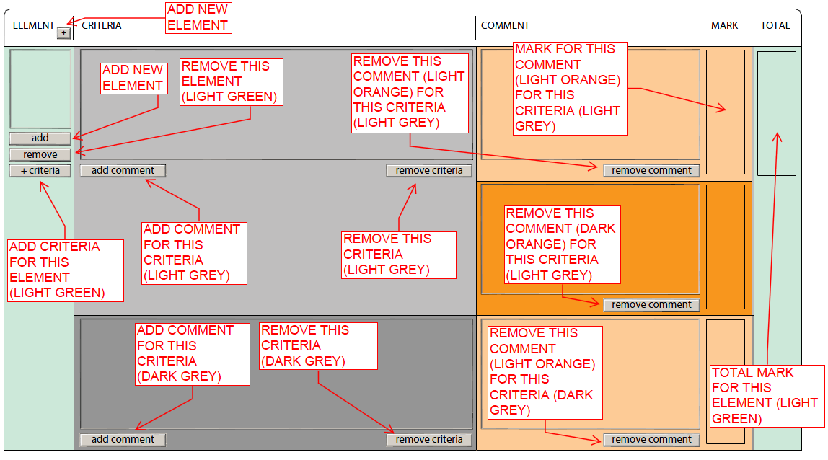

Figure 26: Rubric Buttons and Fields

Figure 26 below shows a filled in Rubric with text filled in that explains the relationship between an ELEMENT and its CRITERIAS and COMMENTS.

The Lecturer will setup the rubric using the add and remove buttons and adding the necessary text.

LECTURER must fill in the ELEMENT, CRITERIA and TOTAL fields.

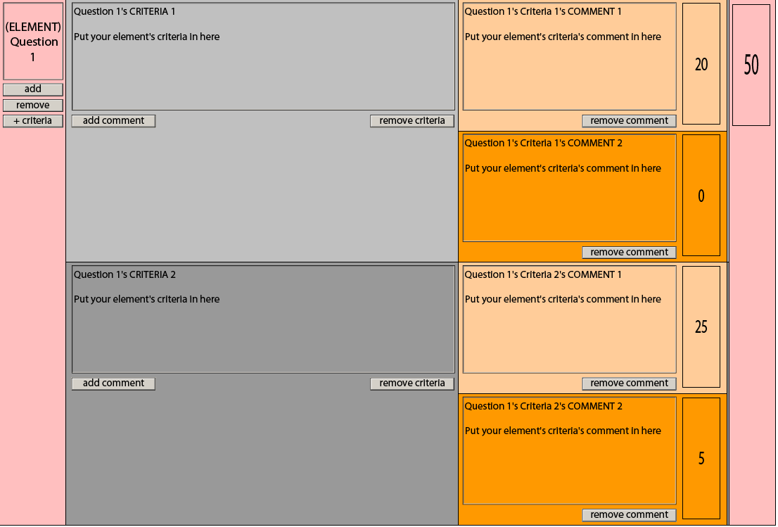

Figure 27: Filled in Rubric (LECTURER MODE)

Figure 27 below shows a filled in Rubric ready for a marker.

The marker can edit/modify COMMENTS and MARK fields setup/advised by the lecturer.

Should the marker wish to add his own COMMENTS, he/she can simply click the ADD COMMENT button.

By clicking the KEEP checkbox under a COMMENT box, allocates the associated COMMENT and MARK to the final Assignment Rubric destined for the Student.

Each CRITERIA must have at least 1 KEEP check box checked.

If a KEEP checkbox is checked, it’s associated COMMENT and MARK fields must be filled in.

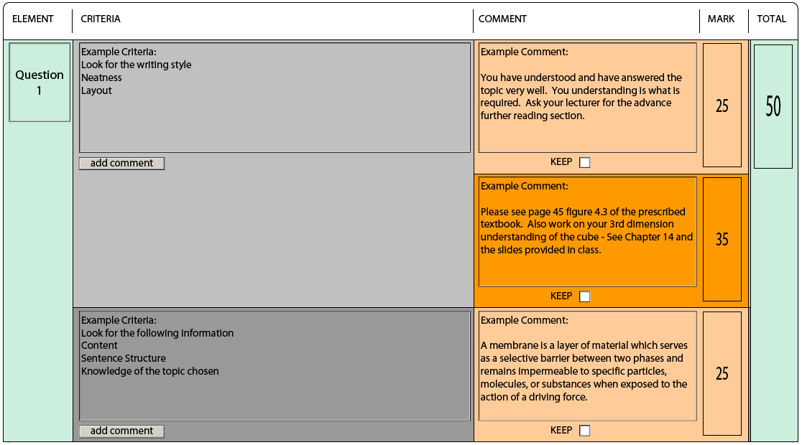Figure 28: Rubric in MARKER MODE

Figure 28 below shows a filled in Rubric ready for student presentation.

All fields are non-editable and no buttons are visible. This is a read only report for the student.

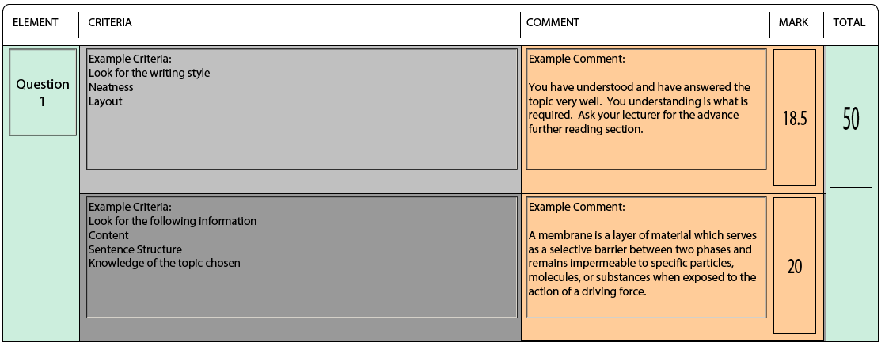 **Figure 29: Rubric in STUDENT MODE**

Figure 29 below shows a filled Rubric header.

The LECTURER must fill in the **Course Code** and **Assignment No.** fields.

The MARKER must fill in the **Student Number** and **Marker** fields.

The **Date Marked** and **Rubric Created** (not currently visible) fields are automatically populated.

The **Progress** section, shows who has interacted with the Rubric and what status the rubric is in.

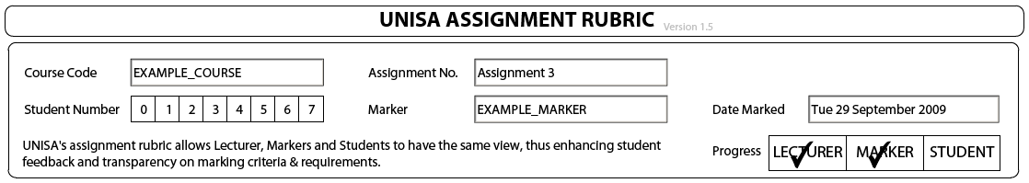 **Figure 30: Rubric HEADER**

Figure 29 below shows a filled in Rubric’s result footer.

The **General Comments** is a free text / communication section for the Lecturer / Marker.

The RESULT fields are automatically calculated, based on the sum of the ELEMENT TOTALS and number of COMMENTS who have their KEEP checkboxes checked.

The PERCENTAGE is automatically calculated, based on the result fields

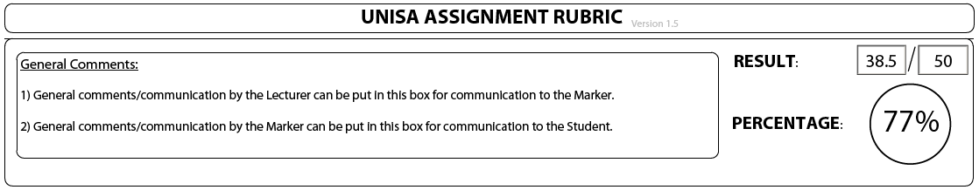 **Figure 31: Rubric Result FOOTER**

Approval Signatures

Whilst functional specifications are always evolving, due to changes in business world and end-user requirements, it is very necessary at key stages within in an iterative project cycle to agree on what the requirements are of the project. Our signatures below agree that the functional specifications and documentation laid out above meet the current requirements of the project.

|  |  |  |  |  |
| --- | --- | --- | --- | --- |
| **Company** | **Designation** | **Name** | **Signature** | **Date** |
| Aesir | Developer | Kyle Bowden |  |  |
| Aesir | Test Manager | Herman van Wyk |  |  |
| Aesir | Chief Technology Officer | Luigi D'Amico |  |  |
| UNISA |  |  |  |  |
| UNISA |  |  |  |  |

Table 1: Approval Signatures